DFT and Spectral Window Plug-In
Introduction
This plug-in implements the ‘classic’ Fourier analysis algorithm (Deeming, 1975). In addition, it calculates the spectral window, i.e., an aliasing pattern (https://en.wikipedia.org/wiki/Aliasing).
The plug-in can be installed via the Plug-in Manager item in the Tool menu. After VStar has been restarted, the Analysis menu will contain a new item for the plug-in:
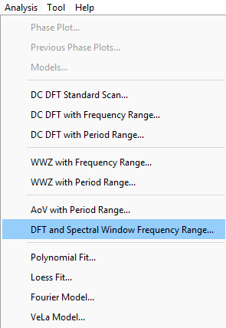

Suppose the following eta Aql data set (JD 2460375 to 2460654) is loaded into VStar:
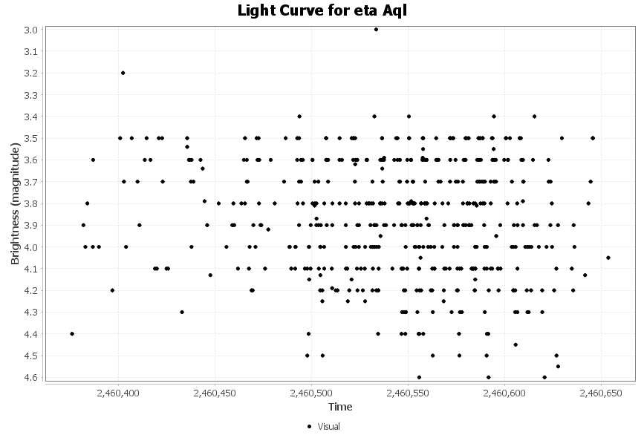
Invoking the DFT and Spectral Window Frequency Range item from the Analysis menu opens a series selection dialog:
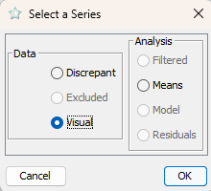
Clicking the OK button with the Visual series selected results in a parameter entry dialog being opened:
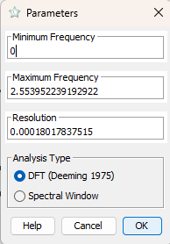

The default values of the maximum frequency and resolution are a good starting point.
(to-do: explain how the default values are calculated)
The result of clicking the OK button with these parameters is shown below:
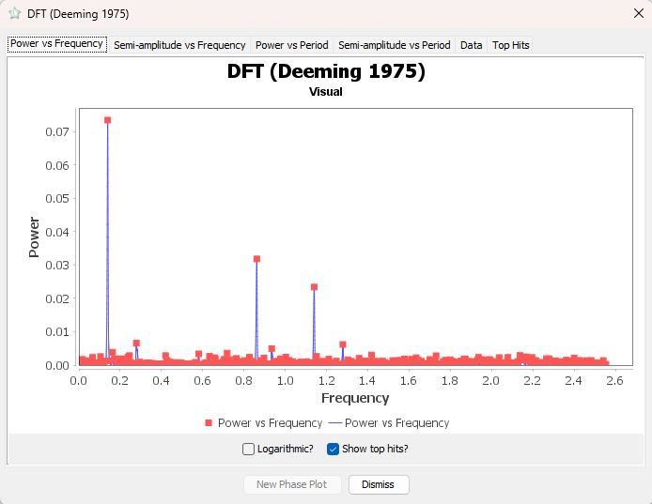

This should look familiar to anyone who has used DCDFT in VStar. As for DCDFT, top hits are shown as red squares on the plots and in tabular form on the Top Hits tab.
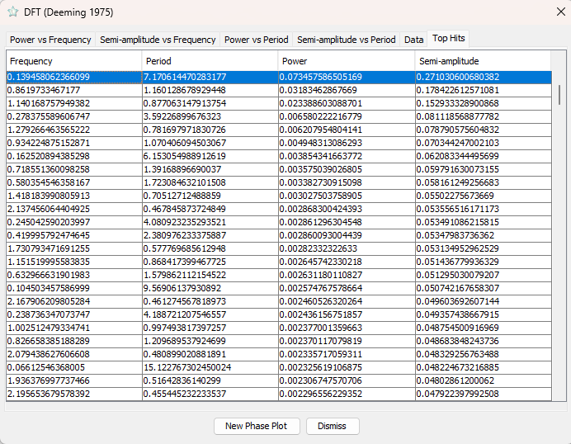

A point on the plot or a table row can be selected, and a phase plot can be created by clicking the New Phase Plot button.
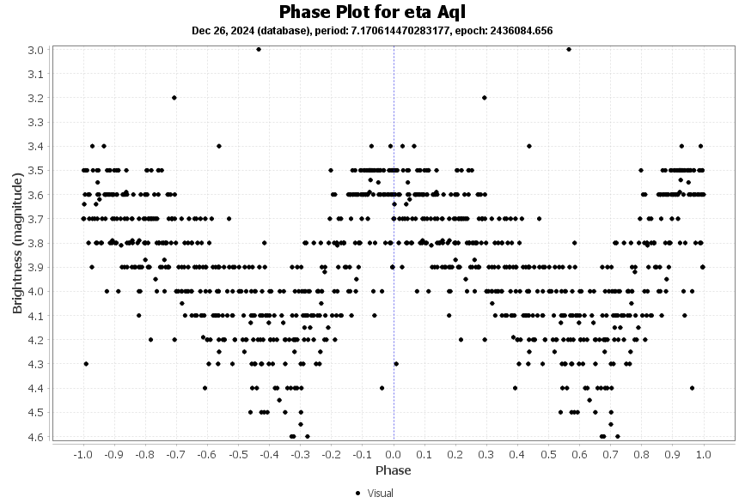
.
Spectral Window
Not all peaks on the periodogram reflect the "real" frequencies in the star's oscillation spectrum. Some of them are aliases that occur due to gaps in the observations, finite observation interval, and the fact that the observations cannot be done in the daytime. Since we can only observe at night and observers are not uniformly distributed by longitude, there are commonly gaps with a period of 1 day. Let's inspect the spectral window calculated for the data above.
To do this, invoke the DFT and Spectral Window Frequency Range item from the menu, then choose the Visual series, and, in the Parameters dialog, click the “Spectral Window” radio button. You will see the following pattern:
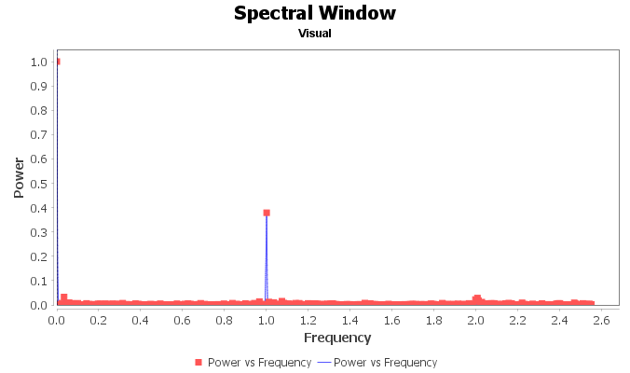
There is always a peak at zero frequency. The width of this peak corresponds to the theoretical resolution of the analysis (the wider the observation time span, the narrower this peak is). However, we can also see a peak at the frequency of 1 d⁻¹. This is an alias. Look at the periodogram we calculated before. Along with the primary peak at the frequency 0.139 d⁻¹, you can see a peak at 1.140 d⁻¹, an alias of the primary peak. It has no physical meaning and is a calculation artifact.
So, the spectral window is a helpful tool to find and reject aliases.

References
Deeming, T. J., 1975, Fourier Analysis with Unequally-Spaced Data, Astrophysics and Space Science, Volume 36, Issue 1, pp. 137-158, Bibcode: 1975Ap&SS..36..137D

Revision History
Rev | Date | Description | Author
A | 26.12.2024 | Initial release | Maksym Pyatnytskyy (PMAK), partially based on David Benn’s AoV plug-in documentation.

